Project Analysis

Project Description
Title: Volleyball Management System
Description: The Volleyball app allows users to manage volleyball teams, players, coaches, training venues and trainingsessions. Teams can train in multiple venues, and venues can host multiple teams. Each team has multiple players and exactly one coach. The app enables the addition and management of these entities, providing an organized overview of the relationships between them.

User Stories
- As a User:
I’m able to manage players so that I can ensure the team is well-prepared for matches.
  - Wireframe: A dashboard showing the list of players, their details, and options to add, edit, or remove players.
  - Acceptance Criteria:
    - The admin an see, edit and remove players
    - The coach can view a list of all players.
    - The coach can add a new player with details like name, age, and license.
- As a User:
  - I’m able to manage teams so that I can ensure every player has a soothing team.
  - Wireframe: A dashboard showing the list of teams, there details, and option to add, edit, or remove teams.
  - Acceptance Criteria:
    - The admin can see, edit and remove teams
    - Player and coaches can only see their own teams
- As a User:
  - I’m able to manage halls so that I can ensure every teams has a place to train
  - Wireframe: A dashboard showing the list of halls, there details and options to add, edit or remove halls
  - Acceptance Criteria:
    - The admin can seen edit and remove teams
    - Players and coaches are not able to see, edit or remove any of the halls
- As a User:
  - I’m able to manage training sessions so I can ensure every team has their own moment to train
  - Wireframe: A dashboard showing a list of training sessions, and an option to add training sessions
  - Acceptance Criteria:
    - The admin is able to see a list of training sessions
    - The admin is able to add training sessions
    - Players and coaches are not able to see or add any training sessions

- As a User:
  - I’m able to login or signup if I don’t have an account yet
  - Wireframe: A login and signup form
  - Acceptance Criteria:
    - An option to login with email and password
    - An option to register (first name, last name, email, password, role) if I don’t have an account yet

Domain Model
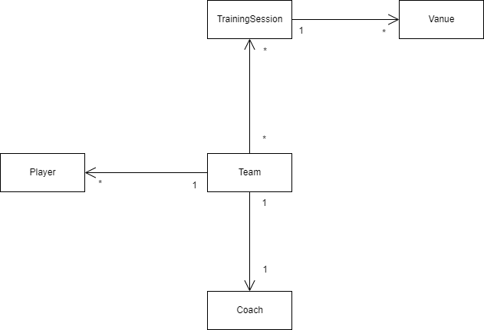

Conceptual Database Model

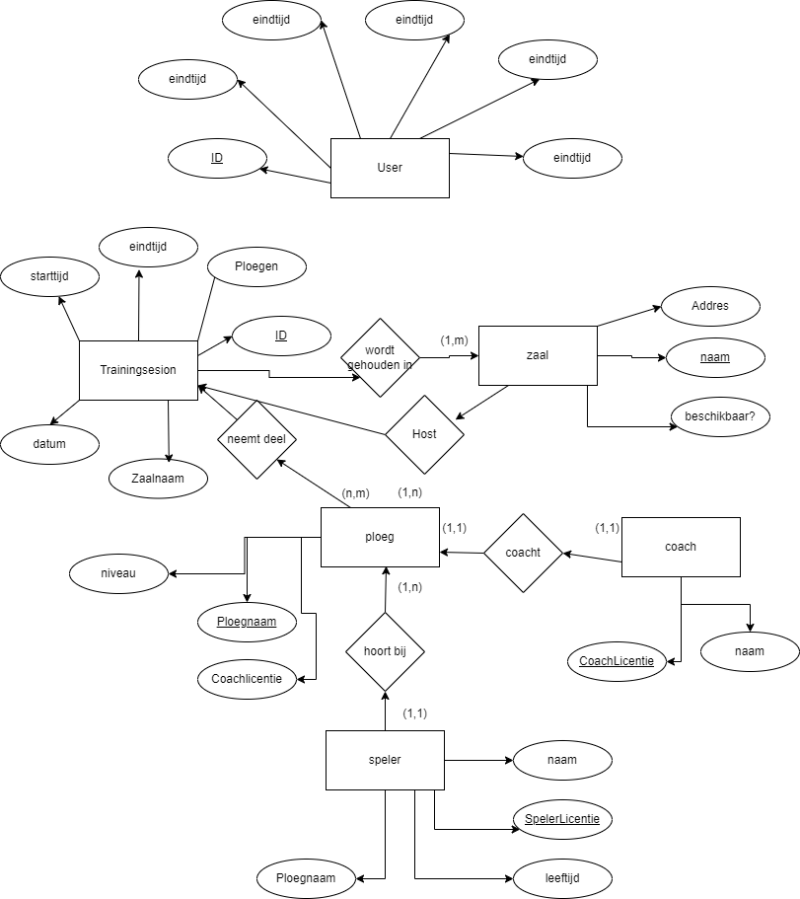

ERD
